# Tableau Mini Project 2

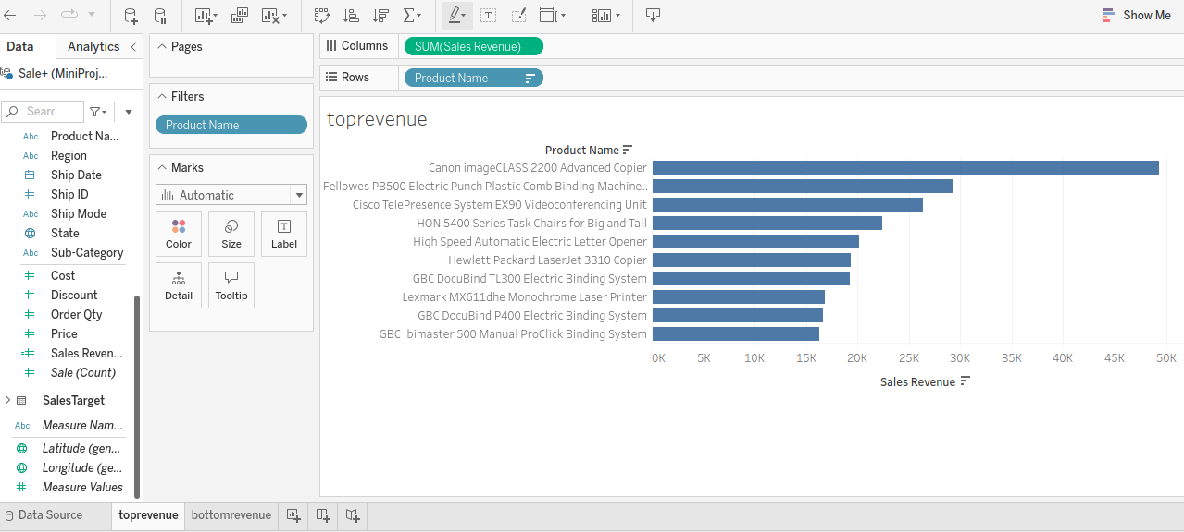

The top three products by revenue are Canon Image CLASS 2200 Advanced Cooler, Fellowes PB500 Electric Punch Plastic Comb Binding Machine and the Cisco TelePresence System EX90 VideoConferencing Unit respectively. The Canon Image CLASS 2200 Advanced Cooler sales revenue far outstrip those of the other top 10 revenue products.

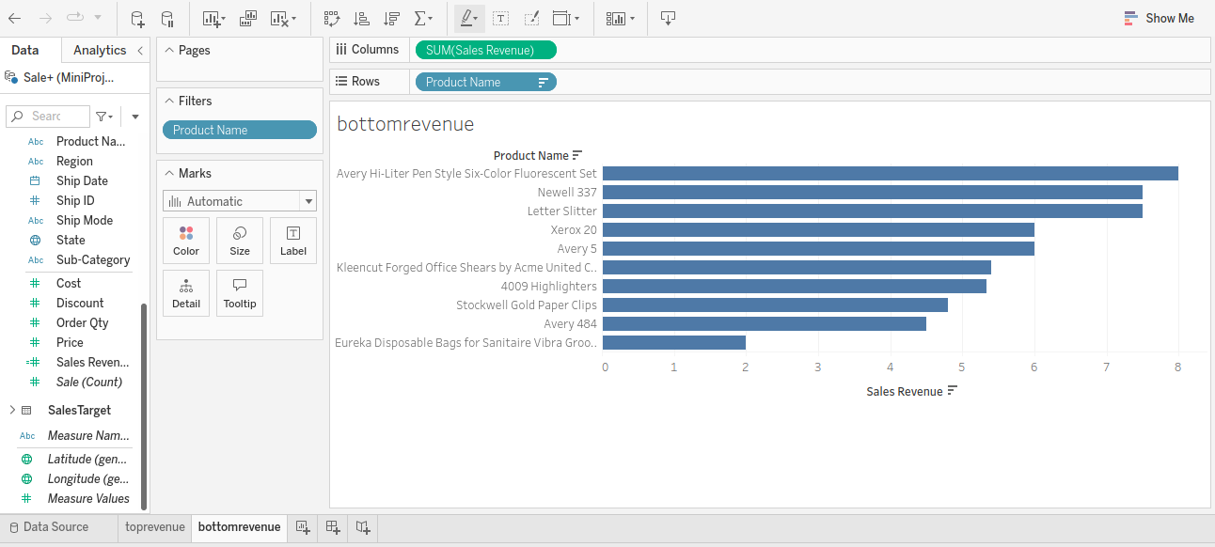

The worst three products in terms of sales revenue are Eureka Disposable Bags for Sinitaire Vibra Grooming, Avery 484, Stockwell Gold Paper Clips and 4009 Highlighters. A look at the bottom products shows that most fall in the stationery category.

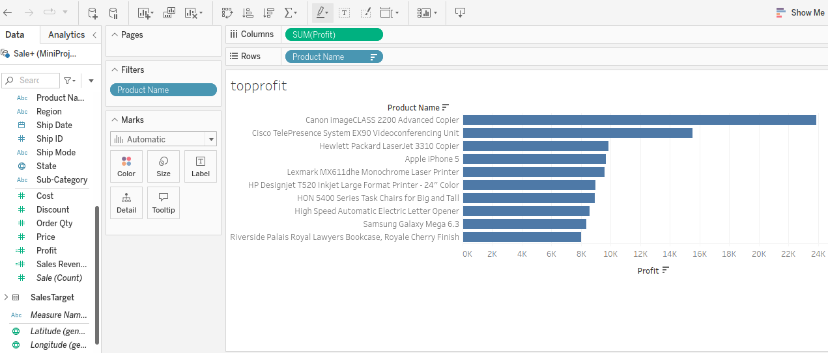

The top three best performing products in terms of profitability are the tCanon Image CLASS 2200 Advanced Cooler, Cisco TelePresence System EX90 VideoConferencing Unit and Helwett Packard LaserJet 3310 Cooler respectively. The Canon Image CLASS 2200 Advanced Cooler profits far outstrip those of the other top 10 revenue products.

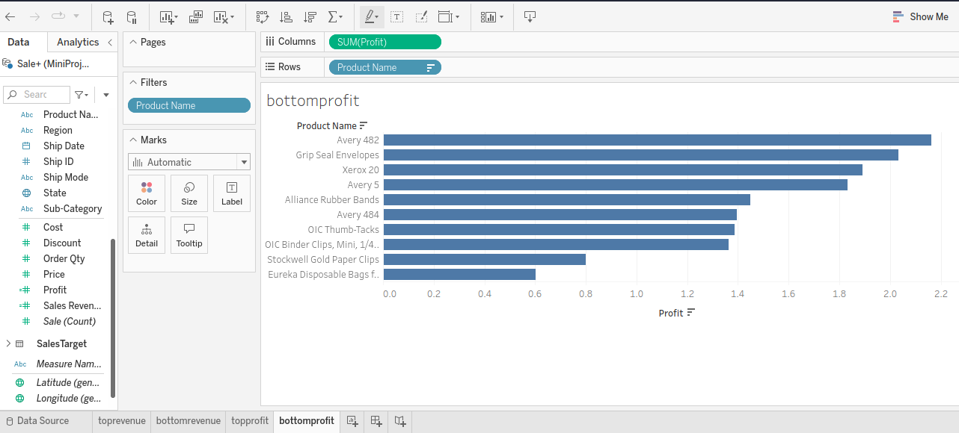

The bottom three products in terms of profitability are the Eureka Disposable Bags for Sinitaire Vibra Grooming, Stockwell Gold Paper Clips and OIC Binder Clips Mini. From the above visualizations, it is clear that the Eureka Disposable Bags for Sinitaire Vibra Grooming should be considered for being dropped from the products on sale.

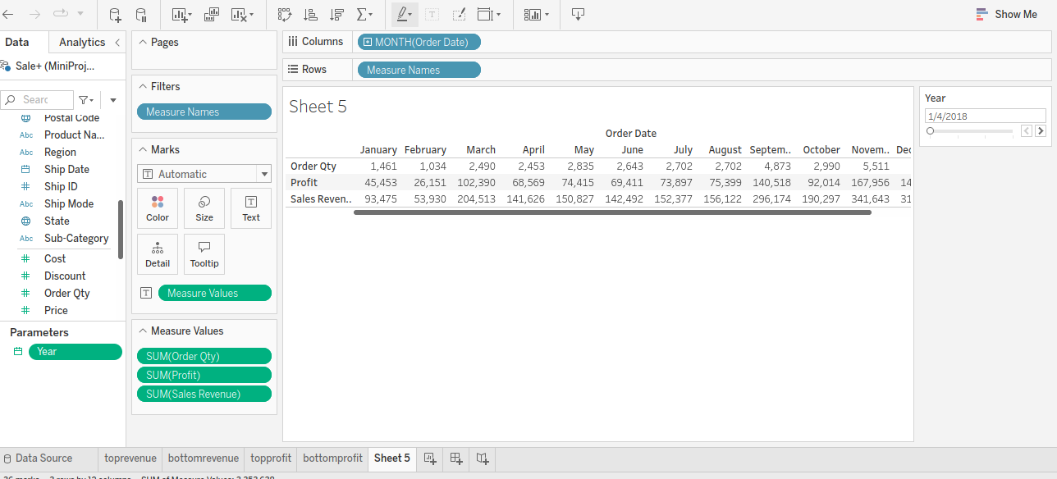

The best months in terms of profitability are September, November and December. The worst performing months are February and January. This could point to a trend that should be explored further in order to maximize profitability.

The parameter was created using the Order Date and selecting Year as the desired parameter. This was used in filtering the Order Qty field, Sales Revenue calculated field and the Profit calculated field.

The cognitive load of the user was reduced by restricting the best and worst performers in terms of revenue and profits to the top/bottom ten using a filter and arranging them in a descending order.